
Company
Logotype

Cone Beam Computed Tomography- Report



Porur Dental X-rays & CBCT

Patient Name : Mrs. Vejiyaletchumy | Date of Report : 30.06.2024
Age/ Gender : 49 years/ Female | Region of Interest : CBCT Full Skull
Referring doctor: Dr. T. S. Meenakshi | Indication : Implant assessment
Clinical Notes: Nil
PATIENT INFORMATION

CBCT- Full Skull provided
CBCT – IMAGE DETAILS

RADIOGRAPHIC INTERPRETATION

- Completely missing crown and root portion in relation to 16, 36.
- The alveolar ridge in relation to the maxillary and mandibular alveolar ridge are present with normal trabecular pattern.
- In the right maxillary sinus, presence of a hyperdense polyp like structure extending from the roof of the sinus evident.

IMPLANT ASSESSMENT

 | 16 region
Sub-Crestal (in mm) | 8.3
Mid- Crestal (in mm) | 9.8
Distance between the alveolar ridge and floor of the maxillary sinus (in mm) | 5.9

 | 36 region
Sub-Crestal (in mm) | 8.1
Mid- Crestal (in mm) | 11.5
Distance between alveolar ridge and the inferior alveolar nerve canal (in mm) | 14.9
Distance between alveolar ridge and the inferior border of mandible (in mm) | 22.7

RADIOGRAPHIC IMPRESSION

- Partially edentulous maxillary and mandibular arch.
- Antral polyp: right maxillary sinus.

Kindly correlate with clinical findings


IMAGES FOR REFERENCE

RECONSTRUCTED PANORAMIC VIEW

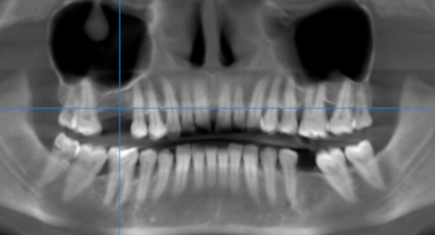

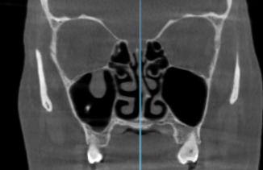

Antral polyp

3-DIMENSIONAL VIEW

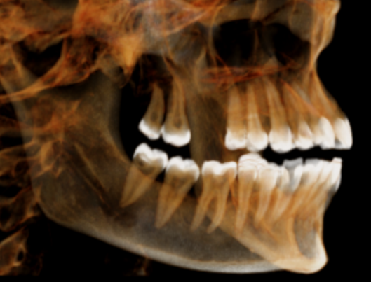

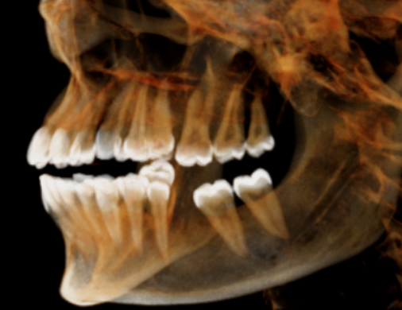

CROSS SECTIONAL VIEW

16 region | 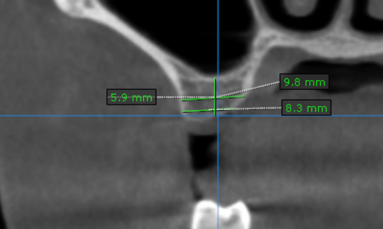
36 region | 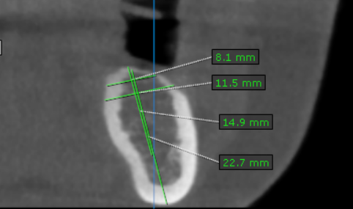

**** End of report ****

